**Fuzzy Expert System Report:**

**A Fuzzy Expert System Recommendation System**

YI WEIYING 1155026053

1. Introduction

Fuzzy expert system is a powerful tool to help you make decision using fuzzy logic [1]. In a work, whenever you want to make a decision that requires specialized knowledge and you want the decision to be “optimal” (i.e. you want to choose the table with relative high cost/performance ratio), you need a fuzzy expert system to help.

In fact, this first decision making scenario that pops up while I was working on this project is “What kind of fuzzy expert system I want to implement?”. This is a question that requires specialized knowledge and I want an “optimal” solution (i.e. easy to implement but expect a high mark). So, why not implement a fuzzy expert system that recommends different kind of topics of fuzzy expert system to the user?

In this project, a fuzzy expert system recommendation system is implemented. In order to simplify the system, only 12 different topics of fuzzy expert system are discussed.

In section 2, the reason of why I want to implement a fuzzy expert system recommendation system is described, along with the usage and advantages of this fuzzy expert system. Then, in section 3, the problem “What kind of fuzzy expert system I want to implement?” is modeled as a recommendation system based on the complexity of the system the user expect and the interest of the user. In section 4 and 5, a detail system design is described and shown. After that, we describe the knowledge acquisition. At last, a discussion is given based on some sample consultations, so does the conclusion.

1. Expert System Solution

Due to the fact that “What kind of fuzzy expert system I want to implement?” is the first question I came up with and it is a decision making question and the questioner wants “optimal” solutions. We believe fuzzy expert system is an appropriate approach to solve this question. Also, such system may help students on ENGG5189 to choose a topic of their fuzzy expert system project in the future.

1. Problem Modeling

“What kind of fuzzy expert system I want to implement?” or “What kind of fuzzy expert system you want to implement?” can actually model as a recommendation system like the board game recommendation system the TA showed in the tutorial. While the board game recommendation system recommends board game to the user based on Strategy, Luck, Interaction and Complexity, the fuzzy expert system recommendation system recommends topics of fuzzy expert system to the user base on the interest(s) of the user and the complexity of the system the user expect. For example, if the user is deep into board games (which implies that the user has specialized knowledge on computer games) and wants a medium complex system, the user will have a high change to implement a board game recommendation system. So, our system will recommend a topic like “board game recommendation fuzzy expert system” to the user. By recommending topics of fuzzy expert system to the users based on their interest(s) and the complexity of the system they expect, we believe our system can provide good results to the users.

1. System Design

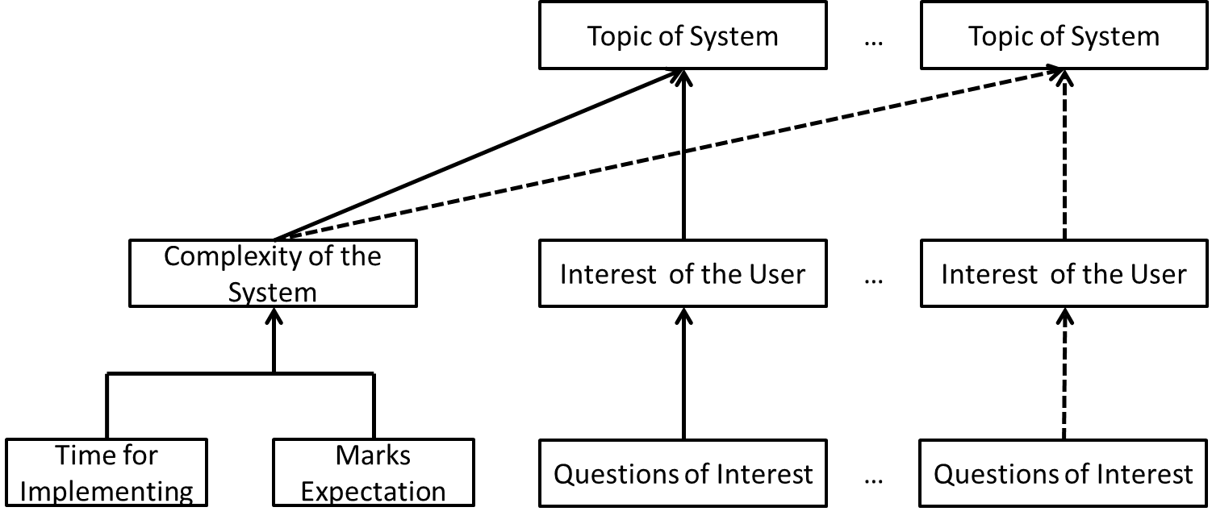

Figure 1: Architecture of the System

As you can see in Figure 1, every arrow in Figure 1 represents one or several RULES that used in the fuzzy expert system. “Topic of System” stands for the recommended topic of fuzzy expert system. “Interest of the User” is a fuzzy term describes how much the user is interested in a specific area. For example, the user is very interested in board games. This fuzzy term can be derived from term “Questions of Interest”. “Questions of Interest” includes one or several questions that can imply the interest area of the user. For example, if a user spends a lot of time on computer games, we can say that the user is interested in games with very high certainty. “Complexity of the System” is the complexity expectation of the user on the system. It is a fuzzy term, if the user wants a very complex system, then the “Complexity of the system” is high. Like the “Interest of the User”, the “Complexity of the System” can be derived from “Time for Implementation” (i.e. the time you have to spend to implement the system) and “Marks Expectation” (i.e. the marks you want to get of this project).

1. Features of Fuzzy Expert System Shell and Inference Structures

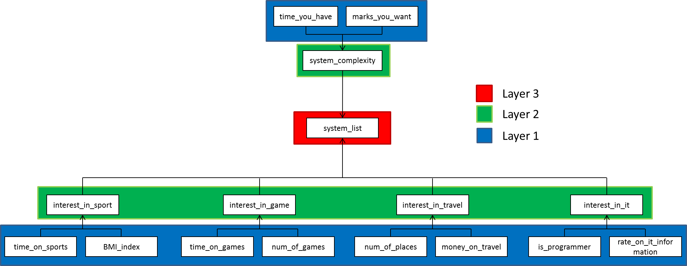

Figure 2: Inference Structure of the System

As you can see in Figure 2, we only consider 4 types of interests in our system. They are interest_in_sport, interest_in_game, interest_in_travel and interest_init. Each of they are fuzzy term with high, mid and low fuzzy value. And for system complexity, it is also a fuzzy term and has high, mid and low fuzzy value.

For system_complexity, it is implied from objects time_you_have and marks_you_want. Object time_you_have represents the time you have for the fuzzy expert system project, while object marks_you_want represents your mark expectation on your project. They are numerical type objects.

For interest_in_sport, it is implied from objects time_on_sports and BMI_index[2]. Object time_on_sport represents the time you spend on sport activates per week, while object BMI_index represents your boday mass index. They are both numerical type objects.

For interest_in_game, it is implied from objects time_on_games and num_of_games. Object time_on_games represents the time you spend on games per week, while object num_of_games represents the number of games you can think of in 1 minute. They are both numerical type objects.

For interest_in_travel, it is implied from objects num_of_places and money_on_travel. Object num_of_places represents the number of places you have travelled to in the last year, while money_on_travel represents the money you spend on travelling every year. They are both numerical type of objects.

For interest_in_it, it is implied from objects is_programmer and rate_on_it_information. Object is_programmer is a yes_or_no type object and rate_on_it_information is a fuzzy_type object.

Finally, based on the interest_in_* and system_complexity, the system_list object is inference. The system_list object is a multiple object that stores the topic of the fuzzy expert systems that are going to recommended to the user.

1. Knowledge Acquisition

Some of the 12 topics of the fuzzy expert system are acquisition from other students and some are made up by me. Although some topics are made up, it doesn’t affect the accuracy our expert system since it is just a name. We can easily change it to other name while we have more suitable topics.

For the certainty of the rules, all of them are made up based on logical analyses. For example, if the users want a high marks for the project and the user has a lot of time to implement the expert system. Then the complexity of the recommended expert system is high with high certainty, while complexity is low with low certainty. Moreover, if the users want a high marks for the project and the user has no time to implement the expert system. Then the complexity of the recommended topic of expert system is low with high certainty, while complexity is high with low certainty.

1. Discussions and Conclusion

Although there are only 4 types of interest included in the fuzzy expert system, it is very convenient to add more types of interest. This is because the interests are independent to each other. Also, it is very convenient to add more objects to derive the interests because of the hieratical inference structure of our expert system.

After five of my friends use this system for consultation, 3 of them feel “good” with the first 3 results, while 1 of them does not “satisfy” the first 3 results and 1 of them suggested that fuzzy set and certainty of each rule can be improved.

Overall, this fuzzy expert system recommendation system recommends “good” topics of fuzzy expert system to the user.

1. Reference

[1] ENGG5189 Fuzzy Expert System Specification, <http://projgw.cse.cuhk.edu.hk:2884/engg5189/assignment/fuzzy_expert_system_spec.pdf>

[2] BMI, Body Mass Index, <http://en.wikipedia.org/wiki/Body_mass_index>

1. Sample Consultations

In the first consultation, we have no time for the project and expectation on marks of this project is low. Also, we show great interest in IT while showing little interest in others interests. In this consultation, we expect a very simple fuzzy expert system that is about IT. The result is shown in Figure 3. And as you can see, the first result is simple_it_system, which meet our expectation.

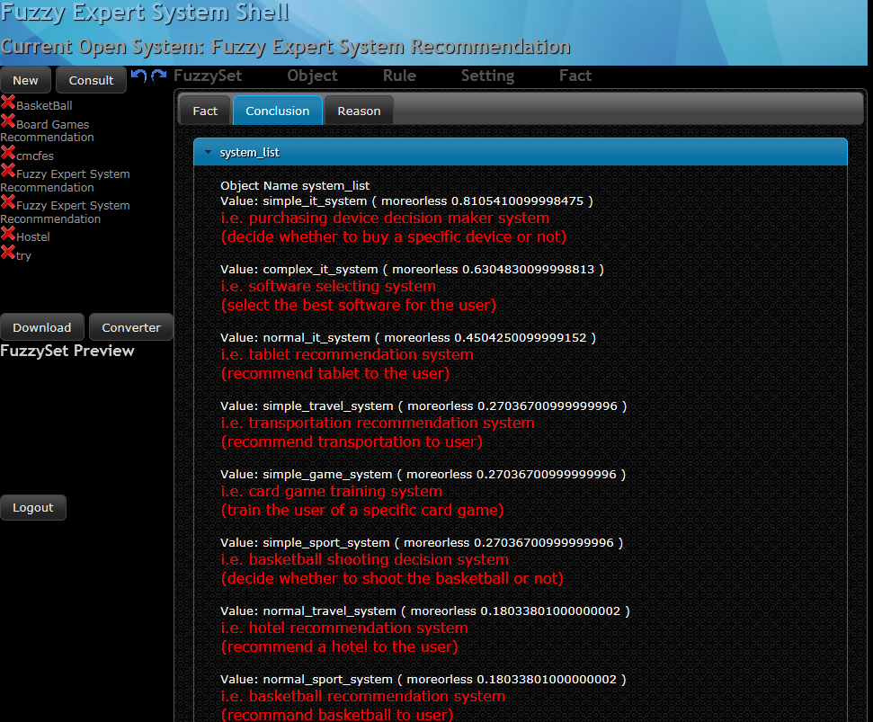

Figure 3: Screenshot of First Consultation

In the second consultation, we have a lof time for the project and expect high marks on this project. Also, we show great interest in IT while showing little interest in others interests. In this consultation, we expect a complex fuzzy expert system that is about IT. The result is shown in Figure 4. And as you can see, the first result is complex_it_system, which meet our expectation.

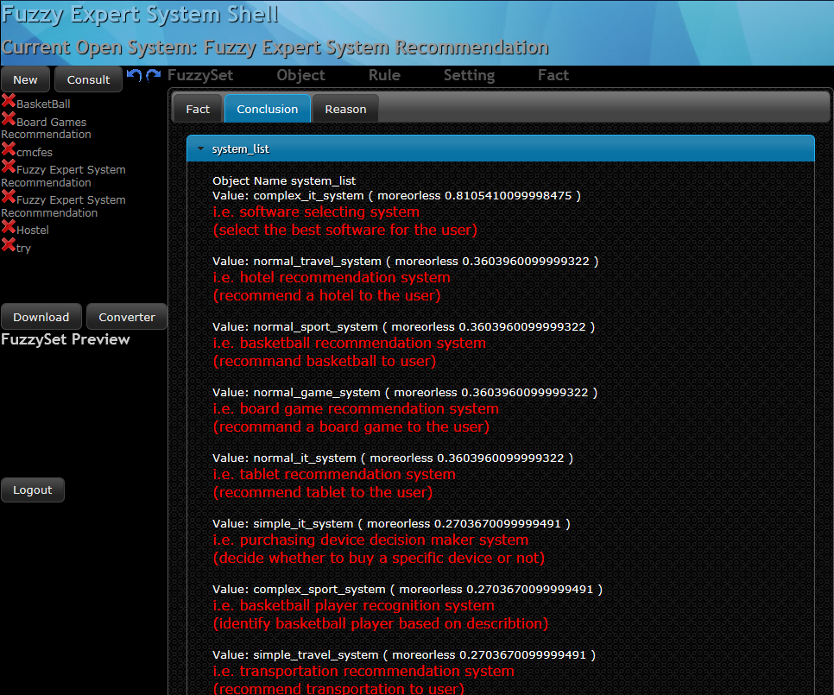

Figure 4: Screenshot of Second Consultation

In the third consultation, we have no time for the project and expect low marks on this project. Also, we show great interest in IT and Sport while showing little interest in others interests. In this consultation, we expect a simple fuzzy expert system that is about IT or Sport. The result is shown in Figure 5. And as you can see, the first two results are system_it_system and simple_sport_system, which meet our expectation.

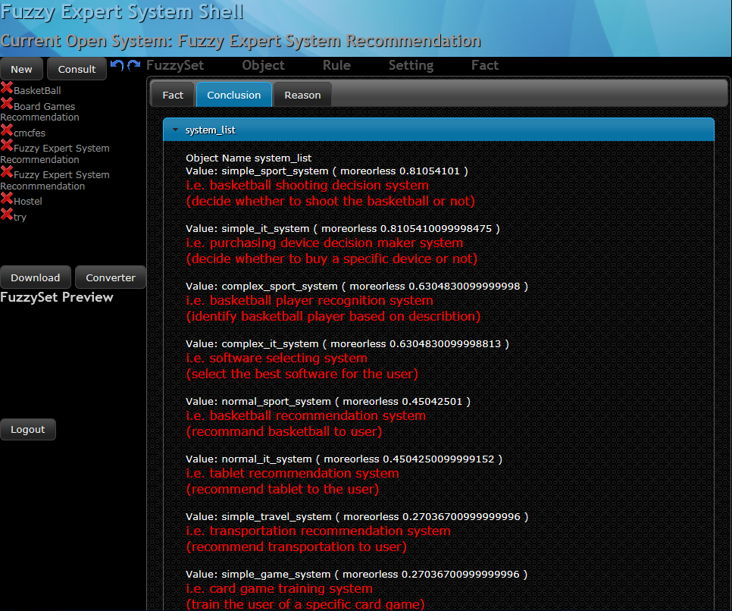

Figure 5: Screenshot of Third Consultation